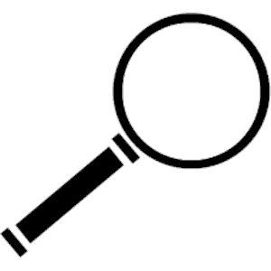
ELEMENTS OF ART FIND IT!
Problem solve and match the words to their definition. Then look around your house to find 3 things that have that match that element. Draw those items in the area below. Have someone photograph you finding the elements in your house.
LINE SHAPE SPACE VALUE
FORM SPACE COLOR

- _ h a _ e
A two-dimensional enclosed space with boundaries defined by other elements of art.

- C _ _ o _
The element of art that is produced by light reflecting off of objects.

- _ i _ e
The path created by a point moving through space.

- S _ a _ e
The area around, inside, or between shapes or forms.

- _ a _ u e
The lightness or darkness of a color.

- T _ x _ _ r e
The way something feels or looks like it could feel.

- _ o r _
A three-dimensional object which encloses volume. It has a height, width, and depth.

